Black Therapist in the Sacramento Area

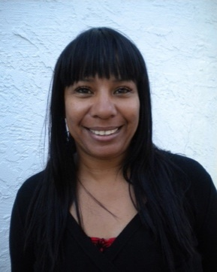
Email Us Send to Friend Website

Mindsets Counseling and Coaching Center

Licensed Professional Clinical Counselor, LPCC, NCC (916) 382-7377

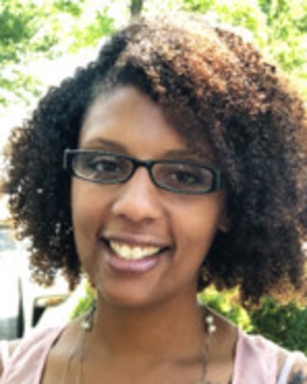

April White
Associate Marriage & Family Therapist, AMFT (270) 736-1229

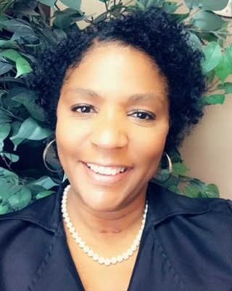
Email Me Send to Friend Website

Jeri White

Associate Professional Clinical Counselor, APCC (916) 866-7741 x3

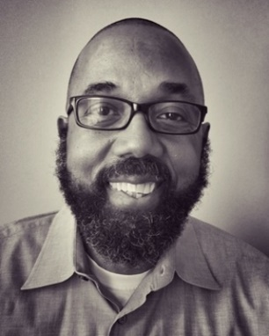
Email Me Send to Friend Website

Gerald Chambers

Marriage & Family Therapist, LMFT
(916) 469-0747

Email Me Send to Friend

April Jordan

Clinical Social Work/Therapist, LCSW
(916) 299-5598

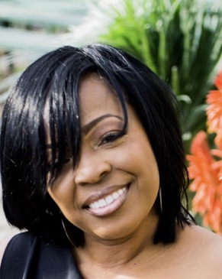
Email Me Send to Friend Website

Arrickia McDaniel

Clinical Social Work/Therapist, EdD, LCSW
(916) 764-3568

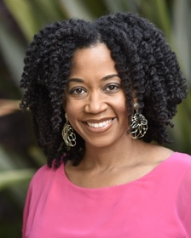
Email Me Send to Friend Website

Tameka Jackson

Psychologist, PhD
(916) 740-1419

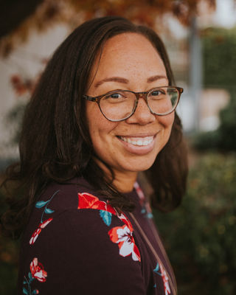
Email Me Send to Friend

Nicole Carter

Clinical Social Work/Therapist, LCSW
(510) 780-3847

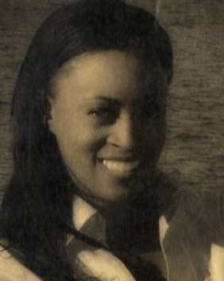
Email Me Send to Friend Website

Renata Peterson

Clinical Social Work/Therapist, MSW, LCSW, CCHT
(916) 778-3116

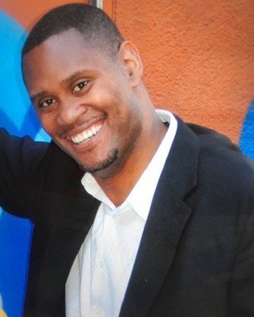
Email Me Send to Friend

James Robert Smith Jr.

Marriage & Family Therapist Associate, MA, MAOM, AMFT
(916) 262-7253

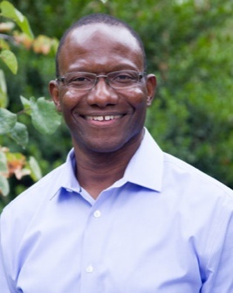
Email Me Send to Friend Website

M Ali Meatchem

Psychologist, PsyD
(916) 525-8644

Email Me Send to Friend

Francine Thompson

Clinical Social Work/Therapist, LCSW
(916) 764-3888

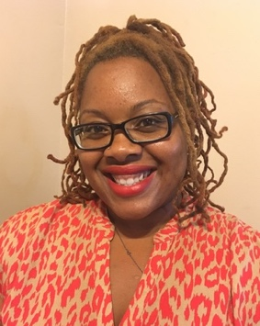
Email Us Send to Friend Website

Innate Guidance

Clinical Social Work/Therapist, LCSW
(916) 621-6028

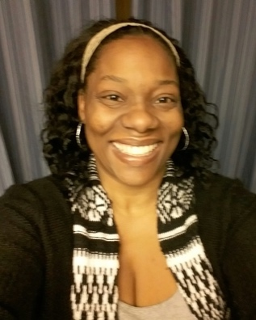
Email Me Send to Friend Website

Rabiia Ali

Marriage & Family Therapist, LMFT
(916) 260-0709

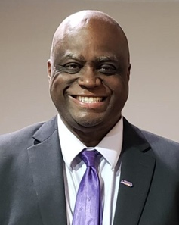
Email Me Send to Friend

Kenneth Watkins

Clinical Social Work/Therapist, LCSW
(916) 461-7745

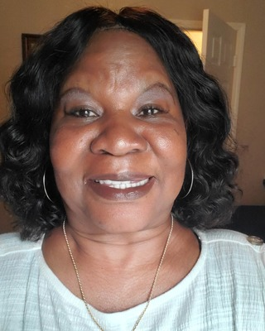
Email Me Send to Friend

Mary K Williamson

Clinical Social Work/Therapist, MSW, LCSW
(916) 546-3677

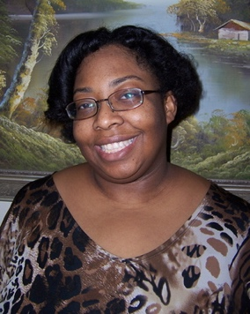
Email Me Send to Friend Website

Tinelle Evans Reno

Licensed Professional Clinical Counselor, LPCC
(916) 237-1471
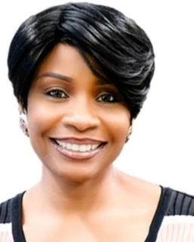
Email Us Send to Friend Website

Breaking Chains Through Change

Clinical Social Work/Therapist, LCSW, EdD
(279) 800-4768

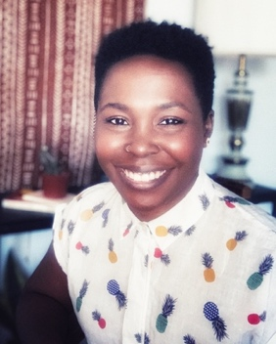
Email Me Send to Friend Website

Questella Alfred

Associate Clinical Social Worker, MSW, ASW
(916) 999-7897
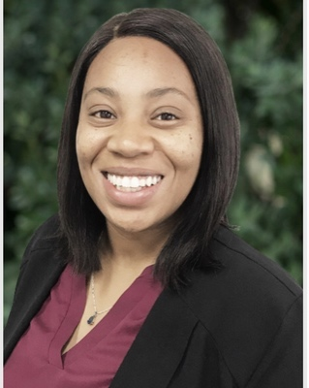
Email Me Send to Friend Website

Denisha Forch

Marriage & Family Therapist, MA, LMFT
(949) 799-3332

Email Me Send to Friend Website

Medina Milan Allen

Marriage & Family Therapist Associate, AMFT, APCC
(916) 796-4685
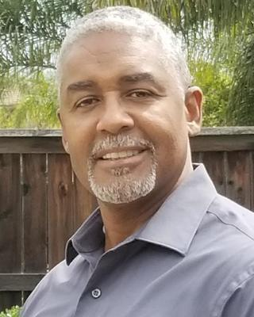
Email Us Send to Friend Website

Delivered2Choices
Drug & Alcohol Counselor, MA, SAP (916) 675-3970

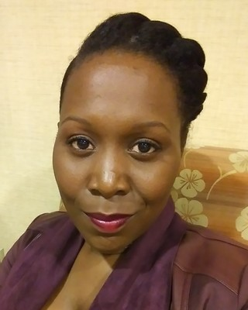
Email Me Send to Friend Website

Ameshia Arthur
Clinical Social Work/Therapist, LCSW (916) 432-1252 x1

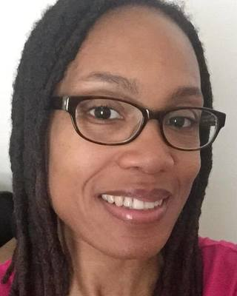
Email Me Send to Friend Website

Melanie J Hubbard

Associate Professional Clinical Counselor, MS, NCC, APCC (916) 259-7834

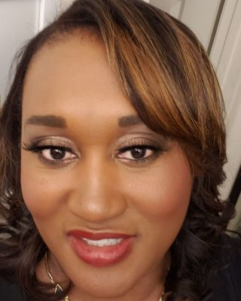
Email Us Send to Friend Website

Dialogue with Diseph
Marriage & Family Therapist, MA, LMFT (916) 580-2807

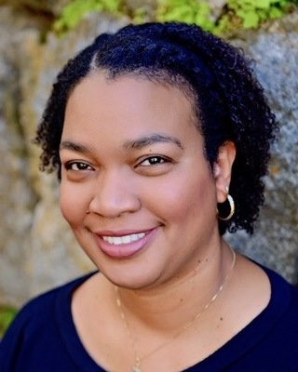

Email Me Send to Friend

Andrea Conner

Associate Marriage & Family Therapist, MA, AMFT, APCC (916) 764-3063

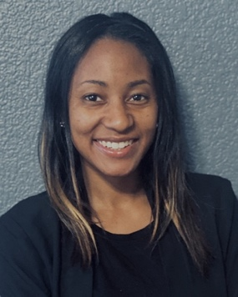
Email Me Send to Friend

Angela Hall
Clinical Social Work/Therapist, LCSW (916) 587-4509
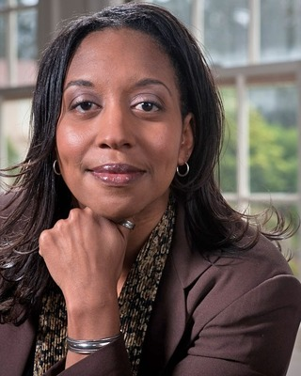
Email Us Send to Friend

Heather Nelson Brame, LCSW

Clinical Social Work/Therapist, LCSW
(415) 813-6517
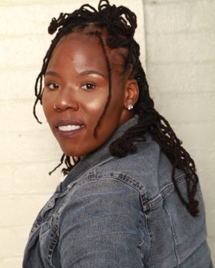
Email Me Send to Friend Website

Kyrra K Christian
Marriage & Family Therapist Associate, MS, AMFT (916) 237-9489

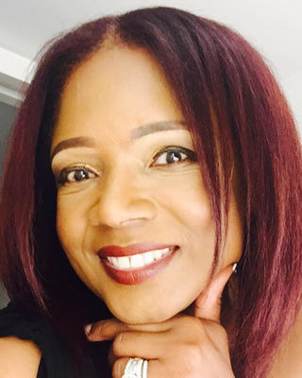
Email Me Send to Friend Website

Crystal Harper

Pastoral Counselor/Therapist, DMinCC, LCPC, CTSS (916) 579-7621

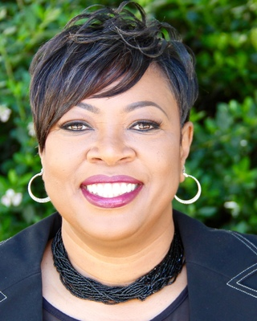
Email Me Send to Friend Website

Debrah D. DeLoney-Deans
Marriage & Family Therapist, MA, LMFT (916) 978-1852

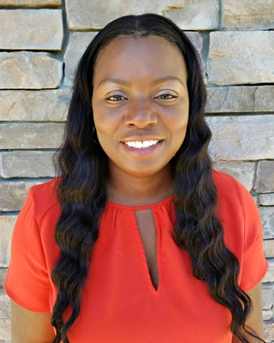
Email Me Send to Friend Website

Dr. Theresa Boswell Phd Lcsw
Clinical Social Work/Therapist, PhD, LCSW (414) 519-9017

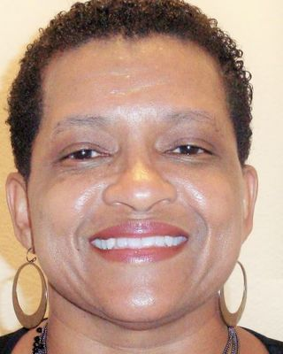

Sandra McBride

Marriage & Family Therapist, MS, LMFT
(916) 579-7692
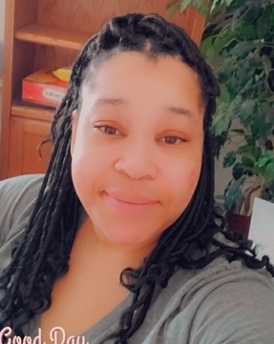

Karessa J Kelly
Marriage & Family Therapist Associate, AMFT (916) 237-1619

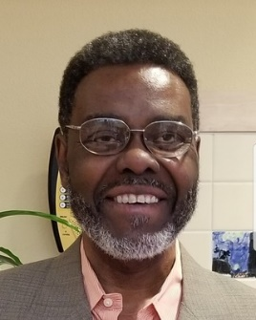

Arthur Day

Marriage & Family Therapist, MA, LMFT (323) 909-4138

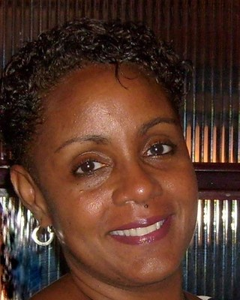

Susan Little

Marriage & Family Therapist, LMFT
(916) 587-5197

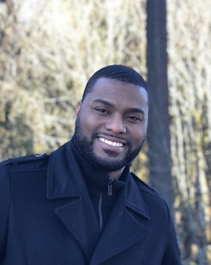
Email Me Send to Friend Website

Bryant Howard

Marriage & Family Therapist, MA, LMFT
(916) 571-0375

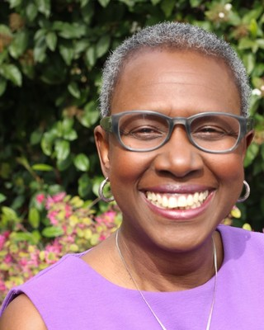
Email Me Send to Friend Website

Martha McClellan-Morehouse
Marriage & Family Therapist, MA, LMFT (916) 259-7842

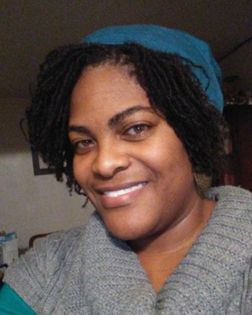

Jocelyn Wilson

Marriage & Family Therapist, LMFT
(916) 507-1612

Email Me Send to Friend Website

Aubrey-Pierre Keys
Marriage & Family Therapist, LMFT (916) 546-4349

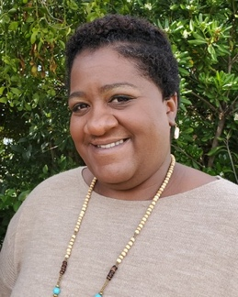

Stacia D. Ponce-Rodriguez
Marriage & Family Therapist, MA, LMFT (530) 364-5248

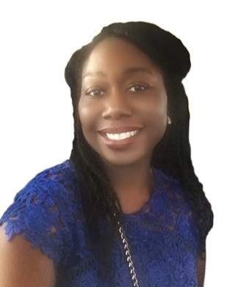

Salatha Helton

Marriage & Family Therapist, LMFT
(916) 249-6917

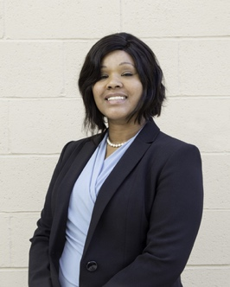
Email Me Send to Friend Website

La Tanya Takla

Psychologist, EdD, LMFT, LPCC
(916) 945-9669

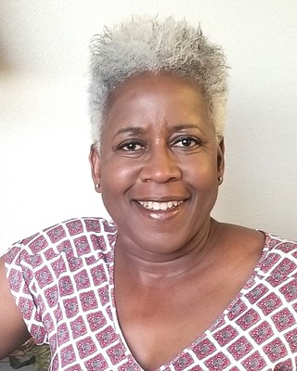
Email Me Send to Friend Website

Nadine Diefenbacher

Marriage & Family Therapist, LMFT
(916) 584-9296

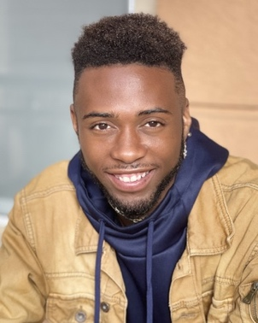

Malik Sampson

Marriage & Family Therapist Associate, MA, AMFT, APCC
(916) 269-3167

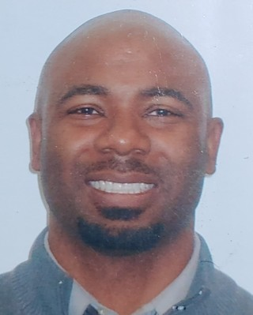

The Fuller Mind Counseling & Therapy Practice

Clinical Social Work/Therapist, LCSW (916) 312-1983

